# 4.3 Procedural Design:

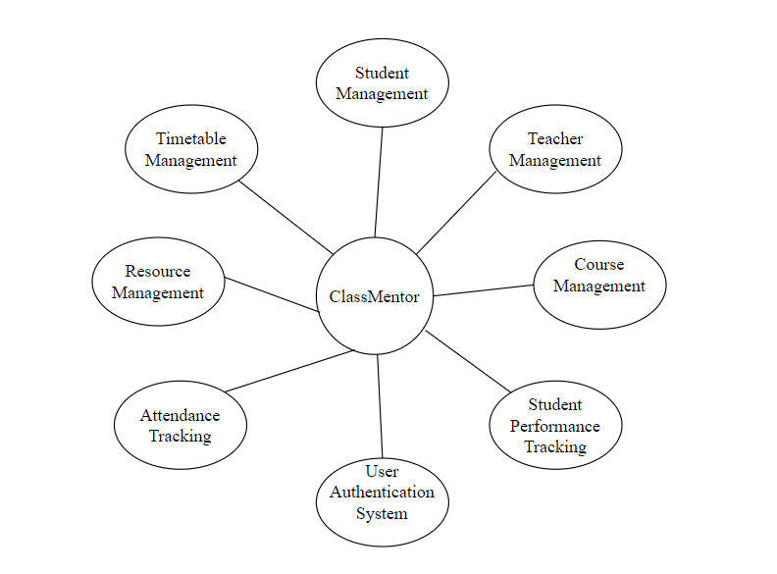

## 4.3.1 logic Diagram:

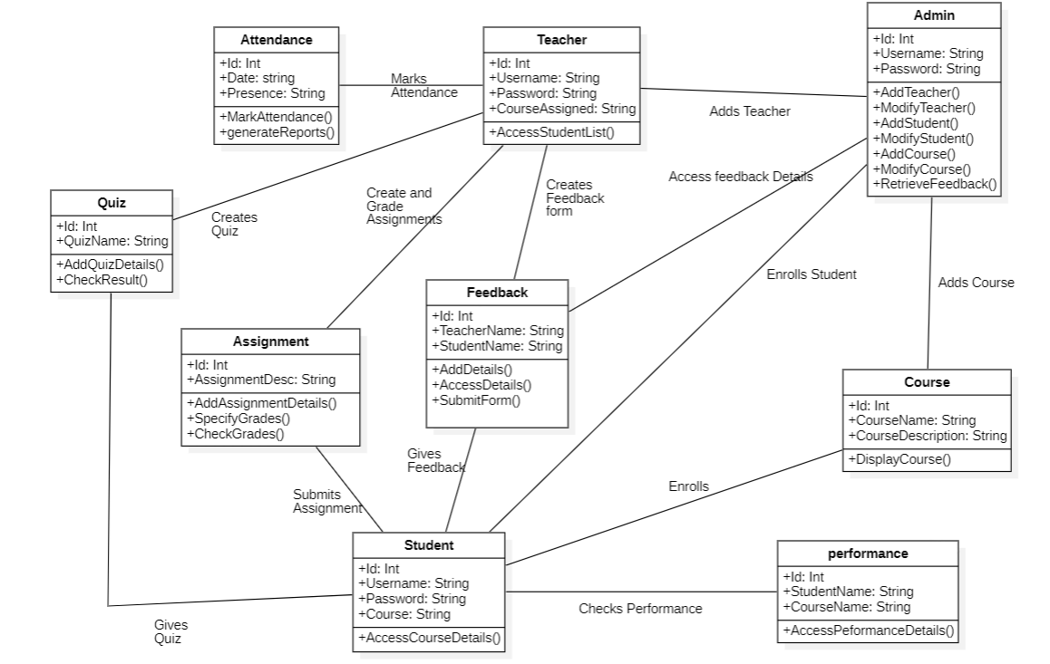

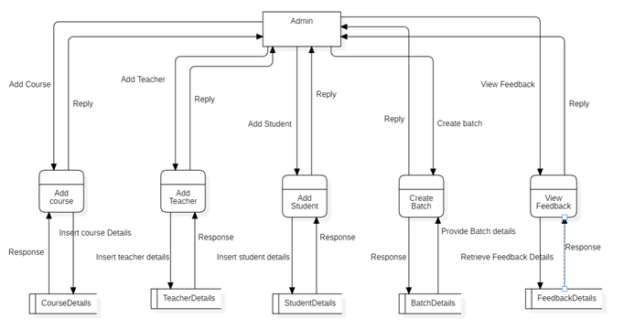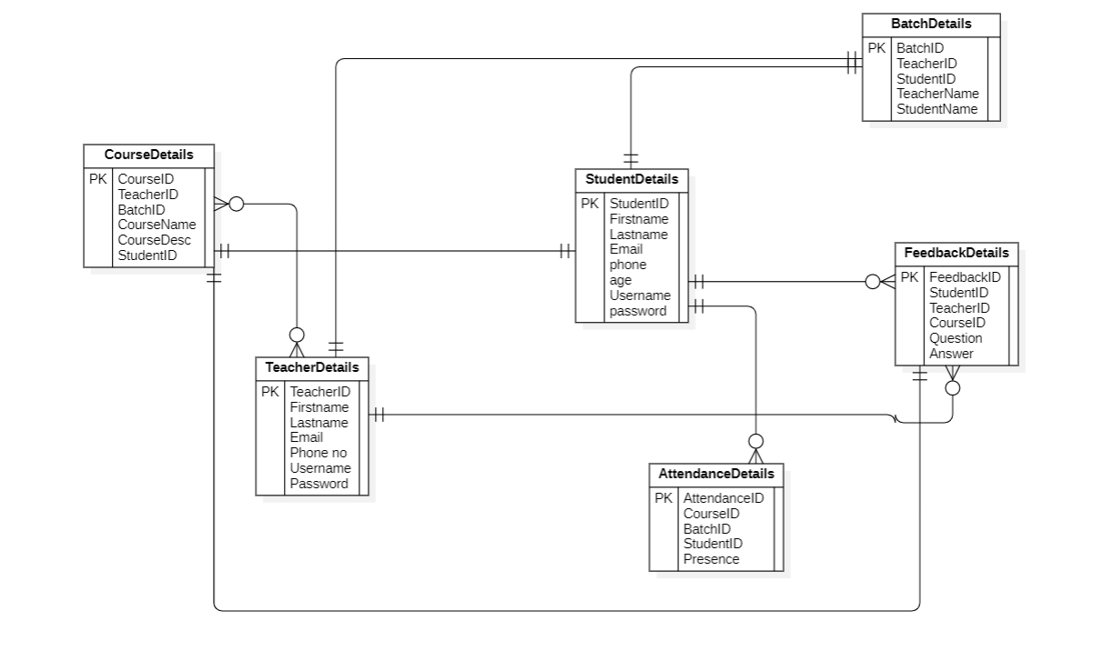

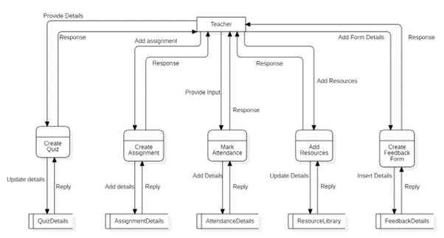

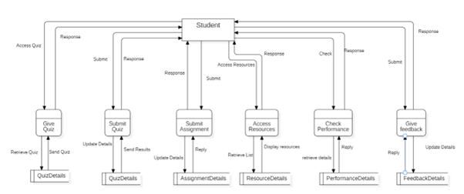

## 4.3.2 Data Structures:

* User List – It will Hold number of Users
* Admin List – It will Hold the number of admins
* Student List – It will hold the number of Students
* Teacher List – It will hold the number of teacher
* Course List – It will hold the number of courses
* Batch List – It will hold the number of batches.

## 4.3.3 Algorithm Design:

**For Admin:**

* **Step 1:** Login to the system.
* **Step 2:** Add teacher, student or course.
* **Step 3:** Assign them username and password.
* **Step 4:** Access the feedback form details.
* **Step 5:** Logout

**For Teachers:**

* **Step 1:** Login with valid credentials provided by Admin.
* **Step 2:** Create Quiz, Assignments.
* **Step 3:** Take Attendance.
* **Step 4:** Add resources.
* **Step 5:** Create feedback Form if necessary.
* **Step 6:** Logout

**For Students:**

* **Step 1:** Login with valid credentials provided by Admin.
* **Step 2:** Give Quiz or submit assignment.
* **Step 3.** Access result or grades from Quiz or Assignment.
* **Step 4:** Access the resources from resource library.
* **Step 5:** Access performance in class.
* **Step 6:** Give Feedback.
* **Step 7:** Logout.